Question 1

Before you can do this exercise, you'll need to download and unzip [this file](https://www.wiseowl.co.uk/files/execise-question-files/qf-487.zip) (**qf-487.zip**

Create a new Power BI report, and load in the data in the above workbook:

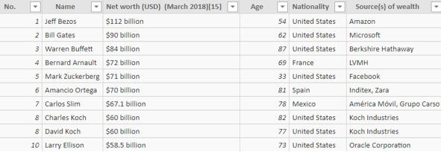

The raw data - your task is to massage it into something more presentable!

Use **Query Editor** to make this data look better:

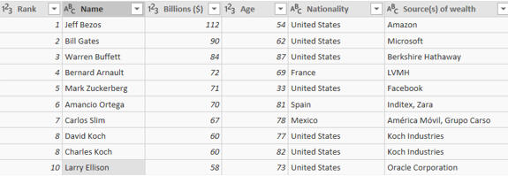

Some columns have been renamed, while each person's wealth (in billions of dollars) has been extracted - see below for how.

If you need hints on extracting the wealth of each person in billions, one way to proceed is to follow these steps:

|  |  |
| --- | --- |
| **Step** | **What to do** |
| 1 | Replace the word **billions** with an empty string. |
| 2 | Replace the $ symbol with an empty string. |
| 3 | Convert the resulting column to a whole number. |

Bring the data back into your Power BI report, and use it to create a simple chart:

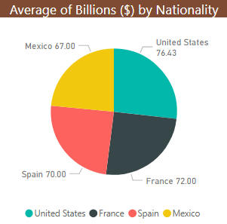

Create a simple chart just to prove that the billions really are being treated as numbers.

Save this report as **But are they happy**, then close it down.

Question 2

**Power BI | Query editor exercise | Load Game of Thrones episode data and tidy it up**

Before you can do this exercise, you'll need to download and unzip [this file](https://www.wiseowl.co.uk/files/execise-question-files/qf-490.zip) **qf-488.zip**

Create a new Power BI report, and load data from the Excel workbook in the above folder into it.  You should see two tables (**Episodes** and **Series**).

Use Query Editor to tidy up the **Episodes** table so that it looks something like this:

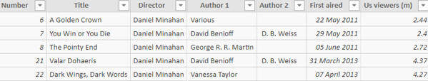

You'll need to split the authors column in two, and replace the resulting nulls with blanks.  You should also filter the data to show only episodes directed by **Daniel Minahan**.

Create a pie chart based on this table showing viewing figures by episode:

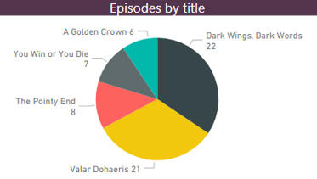

Your pie chart should show how many people watched each episode directed by **Daniel Minahan**.

Save this report as **Danny Boy**, then close it down.

**Question 3**

**Power BI | Query editor exercise | Import the latest FTSE stock market prices using Query Editor**

Before you can do this exercise, you'll need to download and unzip [this file](https://www.wiseowl.co.uk/files/execise-question-files/qf-488.zip) **(qf-488.zip**

Create a new Power BI report.

Load the data from the workbook in the above folder - you should see something like this:

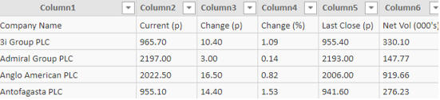

The initial list of shares, which is begging to be tidied up!

In Query Editor, carry out the following transforms:

1. Choose to **Use First Row as Headers** (this may not always be necessary).
2. Remove all but the first, second and fifth columns.
3. Rename the remaining columns as shown below.

You should now be looking at something like this:

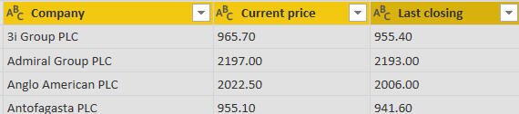

The remaining table of data.

Your prices are left-aligned, which suggests that Power BI is treating them as text.  Change the data types of the last two columns so that they are (decimal) numbers:

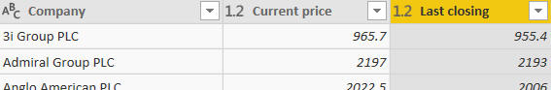

Better - now we can do arithmetic on these columns ...

Choose to add a new column:

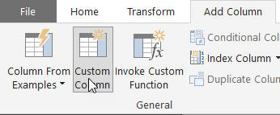

Choose to add a column using this icon.

Create a column which subtracts the last closing price from the current one, rename it and sort by it to get:

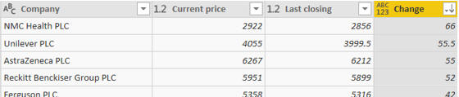

It's been a good day today for holders of shares in **NMC Health PLC**.

Save this data back into Power BI proper, and use it to create a simple table:

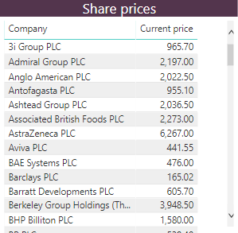

Totals would be meaningless in this context, so you should choose not to display them.

Save this report as **Equity**, then close it down.

**Question 4**

**Power BI | Query editor exercise | Load a table of the world's tallest buildings, and tidy it up**

Before you can do this exercise, you'll need to download and unzip [this file](https://www.wiseowl.co.uk/files/execise-question-files/qf-283.zip) **qf-283.zip**

Create a new Power BI Desktop file, and load a list of the world's tallest buildings from Skyscraper Centre

Add steps to your query so that it creates results like this:

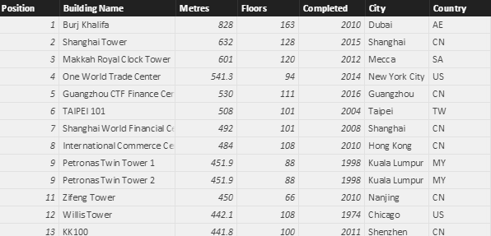

We've lost the height in feet and some other columns, and split the city into **City** and **Country**.

Create a chart comparing the number of skyscrapers for each country:

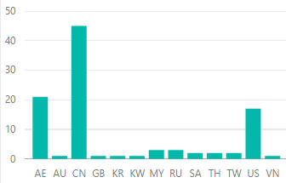

The number of buildings for each country.

Apply a filter to the visualisation within Power BI Desktop itself to show only countries having 5 or more skyscrapers:

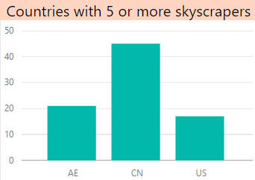

United Arab Emirates, China and the US, if you're wondering ...

Save this file as **Skyscrapers**, and close down the Power BI instance that created it.

**Question 5**

**Power BI | Query editor exercise | Tidy up a list of the top websites using Query Editor**

Before you can do this exercise, you'll need to download and unzip [this file](https://www.wiseowl.co.uk/files/execise-question-files/qf-489.zip) **qf-489.zip**

Create a new Power BI report.  Load data from the Excel workbook in the above folder to get:

Initial list

The initial list of websites (we have much to do).

Make the first row the header row and rename and remove columns to get:

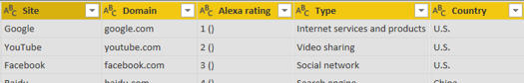

Better - now the fun begins!

Add in a column to number each row, as shown here, and rename the resulting column to **Ranking**:

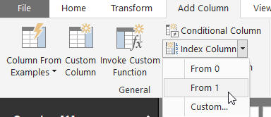

This option effectively numbers each row.

Use splitting columns to derive the current Alexa rank, keeping the number but losing the bit in brackets after it:

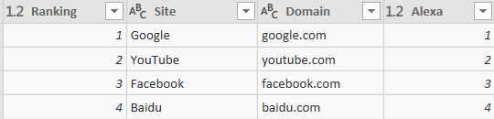

Load this data back into Power BI, and use it to create a chart something like this:

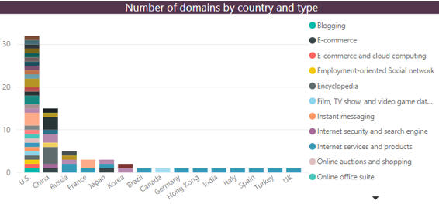

This chart shows how many domains there are for each country and type.

Save this report as **Google rules**, then close it down.

**Question 6**

**Power BI | Query editor exercise | Using the query editor to clean your pokedex**

Before you can do this exercise, you'll need to download and unzip [this file](https://www.wiseowl.co.uk/files/execise-question-files/qf-386.zip) qf-386.zip

With more *Pokémon* being added all the time, it's time to clean up our data (and clear out the trash)! First bring in the data from a reliable source (Wikipedia):

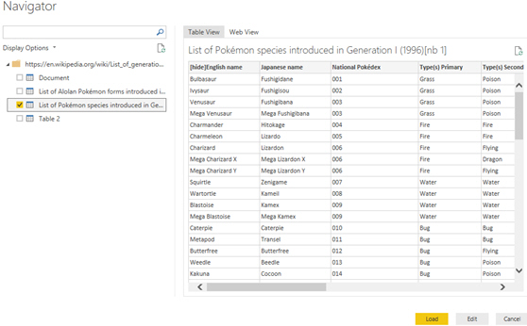

Google **List of generation I *Pokémon***. Alternatively if you don't have internet access, find the Excel file **Crouching Scyther, hidden Porygon.xlsx** in the above folder

Load this into the query editor and get rid of a couple of columns:

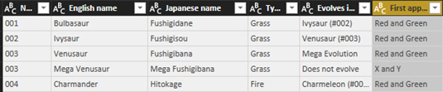

The **Notes** column is gumpf and the idea of **Type(s) Secondary,** is offensive. We've also moved the **National Pokedex** number.

Next get rid of any *Pokémon* who didn't first appear in **Red and Green**. This can been done by applying a filter to the top of the **First appeared** column:

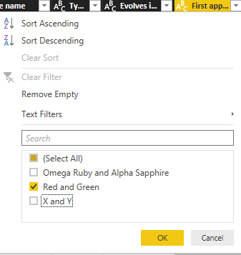

Finally to make our list completely free of any non-originals do a find and replace to remove any reference to **Mega Evolution**:

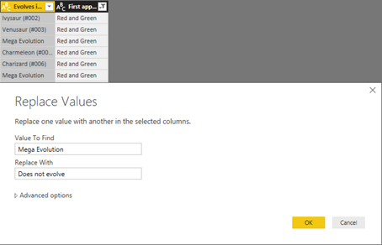

The very idea that **Venusaur** can evolve is just ridiculous and this stupid idea of mega forms has to stop!

Since I no longer need the **First appeared column,** delete it. The column was only there to remove non-essential *Pokémon*.  Now close and apply to save your changes:

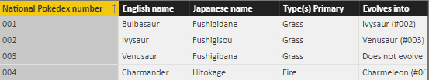

We millennials might not have houses, but we do have avocado toast and *Pokémon*!

Save this as **There are only 151**, then close it down.

Remember if you too want to be a Power BI master:

Question 7

**Power BI | Query editor exercise | Unpivoting data and changing the data source**

Before you can do this exercise, you'll need to download and unzip **First Half.xlsx**

This exercise covers unpivoting data, changing data sources and more besides!  To begin with, create a new report and load the data in the **First Half.xlsx** workbook.

User Query Editor to tidy up this data so that you have something like this:

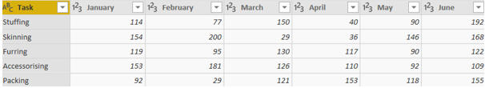

You'll need to remove the top row, then make the new top row into the row headers.

Choose the following option to unpivot the monthly data:

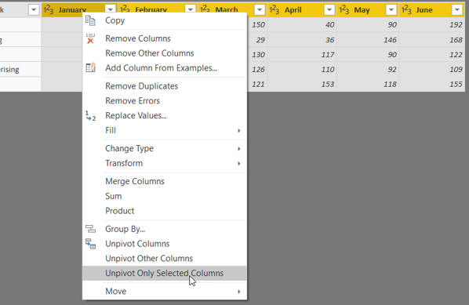

Choose to unpivot the months of data.

After a bit of renaming, you should have this table in Power BI:

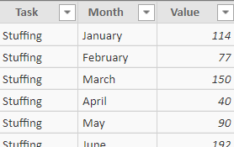

The start of the table of unpivoted data.

Use this to create a chart showing value by month:

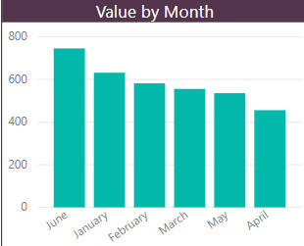

The problem is that we want to sort the months correctly, but to do that you'll need to assign numbers to them.

Go back to **Query Editor** and add a conditional column:

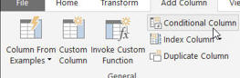

The option to add a conditional column, returning the correct month number for each row.

This should give you something like this:

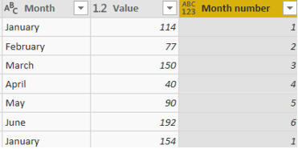

After painstakingly typing in the 6 possible conditions and results, you should have a column turning a month name into a number.

You might have found it easier to do a couple of conditions then edit the M formula for this step to add the other four (it's certainly worth having a look at it to see how easy it is to understand and amend).

You can now choose to sort your month names by number:

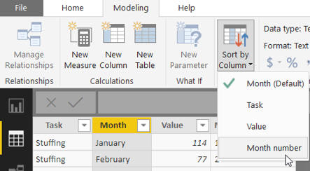

Choose this option to sort your month names correctly.

After checking your chart is sorting by the correct column, you should now have this!

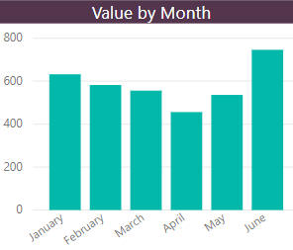

The same chart, but with the correct sort order.

Oh dear – We apologise.  The exercise asked you to link to the wrong file.  Change your M to refer to the file called **Second half.xlsx** (you'll need to go down your query steps making lots of editing changes to resolve errors), then check your chart still works:

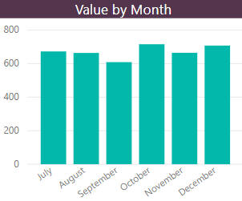

After a lot of retyping in your query step formulae you should eventually get this chart!

Save your report as **The knees of a bee**, then close it down.